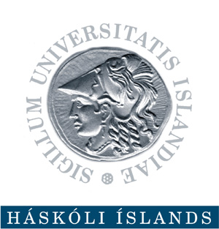 | University of Iceland  Marine Education in Iceland  Institute of Biology  Askja, Sturlagata 7  IS-101 Reykjavik, Iceland  Email: post@marine.is

Application for Admission
University of Iceland Marine and Fisheries Sciences Summer Program

Which courses are you applying for?
LÍF 632M: Data Analysis for Scientists using R
Y/N

LÍF 111M: Marine Mammals
Y/N

Personal Information
Name:
Icelandic kennitala (if applicable):
Gender (M/F):
Date of Birth:
Nationality:
E-mail:
Telephone (inc. country code):

Contact Address (You must be able to receive documents at this address after the course has finished so please ensure it is correct):
Mobile phone (inc. country code):
Education
Current University/Institution (Name, country):

Degree (BSc/MSc/PhD/Other):
Expected graduation (month & year):
Former University/Institution (Name, country):
Degree (BSc/MSc/PhD/Other):
Graduation (year):

DOCUMENTS THAT MUST ACCOMPANY YOUR APPLICATION FORM
1) Official Academic Transcript(s)

Even if you have not yet completed your degree, your University will able to provide you with a transcript of the courses you have taken so far and the grades you have obtained. The transcript can also be for your last completed degree (as long as it has relevance to the course(s) you have applied for here in Iceland).

Please scan your official academic transcript(s), and e-mail it to us with this application form

3) Colour photocopy of your Passport
Please send a COLOUR copy of your passport for registration purposes.

2) Confirmation from your University that they will recognise the course(s)*
You need to confirm with your University that they will recognise the ECTS you gain from the course(s) for your studies at your home University . Here is the information you need:
LÍF 632M: Data Analysis for Scientists using R
4 ECTS, Final grading system: Pass or Fail

LÍF 602M: Fisheries Ecology
8 ECTS, Final grading system: Grade between 1 and 10

LÍF 111M: Marine Mammals
6 ECTS, Final grading system: Pass or Fail
Please include a letter from your University that states they will accept these courses and associated ECTS with this application form.

