Marine Education in Iceland

Introduction
The University of Iceland offers a series of intensive graduate level courses in Marine and Fisheries Sciences during summer, aimed at students pursuing a degree in fisheries science, marine ecology, or biological oceanography.
The program is focused on providing graduate students a one of a kind, immersive experience in fisheries ecology, marine resource management and marine conservation, within the perspective of climate change.
Courses and hands-on fieldwork are conducted at various locations in Iceland, to take advantage of the geographical diversity and enable students to experience a few of the many ‘University Nature Centres’ established in fishing villages throughout Iceland. It is a great opportunity to experience the magic of the long summer ‘nights’ of midnight sun and the natural wonders of Iceland while taking courses and making international connections that will prove useful in your graduate studies and beyond.
All lectures are conducted in English by professors and researchers at the University of Iceland. Additional lectures are conducted by invited guest speakers internationally recognized for their outstanding achievements in their respective fields.
Courses vary in size from 2–8 ECTs and each lasts a period of 1–3 weeks. Each course consists of a mixture of formal lectures, discussion groups, field or laboratory exercises, and computer modelling. In some of the courses, students are expected to complete 1–2 weeks of preparation prior to their arrival in Iceland.

Registration and Costs
The University of Iceland does not charge tuition fees. However, a small registration fee of 20000 is charged to all students regardless of whether they take one course or many courses. Students pay the registration fee after they receive a letter of admission. Details on how to make payments will be provided at the time of admission.
Students are also required to pay for their own travel to/from Reykjavik, accommodation and food/drinks while in Iceland. The University of Iceland will be able to assist students in securing accommodation for the duration of their stay (see General Information for further details).
Please contact us at post@marine.is if you would like additional information.

How to Apply
Students can choose to participate in the entire summer program or select individual courses. Applications can be submitted by e-mail only.
The application form is available at the end of this document or at:
http://marine.is/apply.html
Please ensure the application form is completed IN FULL and ALL required documentation (detailed on the application form) is included with your application.
Applications should be submitted before 30 March 2015.
Please send completed applications to: post@marine.is

Courses in 2014

Data Analysis for Scientists using R
Code: LÍF 632M
Instructor(s): Dr. Niall McGinty
Location(s): Askja, 101 Reykjavik (see Course Locations)
Credits: 4 ECTS
Description: This course will take students through the whole process of collecting, analysing and publishing data using a modern computer system. Emphasis will be placed on seeing the computer as a tool that improves the integrity of data, making it easier to replicate studies and guarantee correctness; and on working in a manner that makes it easy to transfer numerical methods and results into academic publications.
We will begin by discussing how data should be collected to make it suitable for analysis, how files on the computer should be organised, methods to deal with the large number of different data sources dealt with by most scientists, and ensuring that data integrity is retained and that an audit trail is recorded.
We will then learn how to analyse data using R. After installing the (free) software on their own computers, students will learn to write short scripts to do their analysis. This will ensure that their methods can be repeated with alternative data, and that an accurate record of statistical methods and data sources is available when writing scientific papers.
Finally, the process of using R to produce professional quality figures will be explained. The course will end with three days for the students to analyse their own data, producing results and figures aimed at a particular journal.
By the end of this course, students should be able to: i) Store many data files on a computer in an organised manner; ii) Keep track of the source of data, changes to data and methods recorded in laboratory notebooks; iii) Understand the differences between types of data files; iv) Install R on a personal computer; v) Load data from different sources into R, and perform statistical analyses; vi) Implement data analyses using R script files; vii) Write up data analyses and results for a journal, based on R script files; viii) Produce figures to publication standard using R.

Fisheries Ecology: Management and Conservation of Marine Resources in a Changing Ocean
Code: LÍF 602M
Instructor(s): Prof. Gudrun Marteinsdóttir, Dr. Niall MGinty, Dr. Steven Campana (Bedford Institute of Oceanography)
Location(s): Askja, 101 Reykjavik and Sandgerði (see Course Locations)
Credits: 8 ECTS
Description: In order to reliably define the conditions under which fisheries can sustainably operate in the long-term, it is essential to have a thorough understanding of the influence of human activities and ocean climate on the ecology of the stocks in question. Climatic variation has been shown to affect behaviour and distribution of marine organisms. Changes in all of our major fish stocks have occurred in recent decades due to trends in ocean climate. Commercial fishing has also altered those which are exploited, at both the inter- and intra-stock levels. Most often, mortality imposed by fishing is considerably higher than that which occurs naturally. In addition, fishing is inherently selective. Accumulating evidence indicates that fishing has influenced the phenotypic and genetic structure, production, sustainability and recovery potential of harvested stocks.
This course will focus on the ecology of exploited marine fish resources, with particular emphasis on the effects that ocean climate and human activities have on the physiology, biology and behaviour of fish populations.
By the end of this course the students should be able to: i) Identify where the effects of climate change are most likely to manifest themselves within the biological hierarchy; ii) Recognize the potential impact of changing climate to conservation and management strategies; iii) Discuss the importance of considering both biotic and abiotic aspects of marine ecosystems for conservation and management of marine resources; iv) Integrate biological and ecological concepts into conservation and management strategies; v) Evaluate the effectiveness of marine conservation and management strategies in the face of a changing climate; vi) Demonstrate the ability to collect, analyze, interpret, and present (in a written form) data as part of a collaborative team.

Studying Marine mammals in the Wild
Code: LÍF 111M
Instructor(s): Dr. Marianne Helene Rasmussen
Location(s): Húsavík (see Course Locations)
Credits: 6 ECTS
Description: This field course will teach the fundamentals of a suite of field methodologies used in the study of free-ranging cetaceans (whales and dolphins). Students will stay at Husavik, in an integrated field course setting. During week one, students will receive background lectures on the diverse assemblage of dolphins and whales off Husavik, learn the theory and practice the use of each of the different cetacean research methodologies. The methods will include: photo-identification, tracking cetaceans at sea, ship-based survey techniques, behavioural observational techniques, vertical-array acoustics using time-delay methods, towed-array acoustics using beam-forming, bottom-mounted hydrophone recording, and shore tracking using a surveyor's transit (theodolite). Experts will present research seminars focusing on how the methodologies are used in cutting-edge research. Postgraduate students will devise and carry out a specific research project using data collected during the fieldwork. They will present the proposals at the end of week one, and specific protocols will be determined by the entire group. Postgraduate students will work alongside teams of senior undergraduate students who will choose or be assigned a specific methodology. The results of research projects will be presented in an oral presentation and then in a written report. The written reports will be due 2 weeks after the end of the field course.

Course Locations
Institute of Biology, Askja, Sturlugata 7, 101 Reykjavik
The Institute of Biology is housed in Askja, a new building situated on the main University campus located in central Reykjavik (see map). Askja features state-of-the-art lecture halls as well as teaching and research laboratories. It will serve as the base of operations while courses are occurring in the Reykjavik metropolitan area.
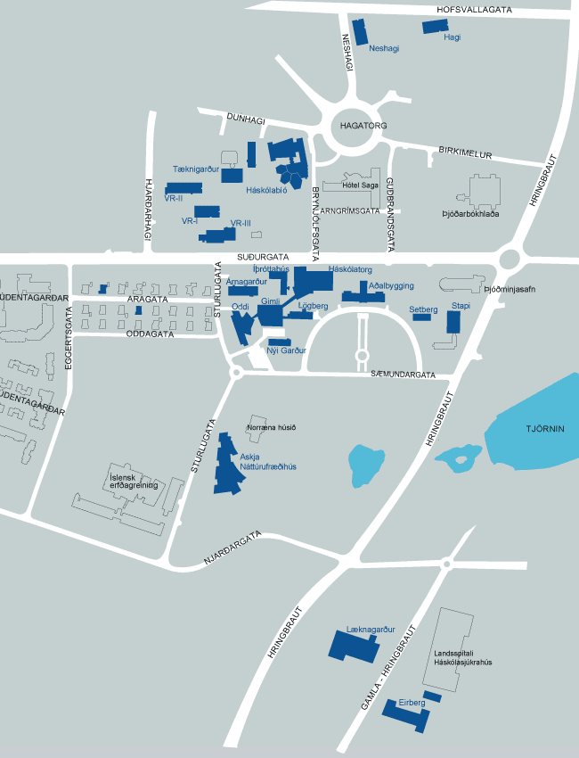
City centre
University of Iceland (Háskóli Íslands)

Marine University Centre, Sandgerði
The Marine University Centre is situated by the harbour in the small fishing village of Sandgerði on the western tip of the Reykjanes Peninsula (see map). It is about a 40 minute drive from the University of Iceland in Reykjavik. The Centre boasts an excellent taxonomic laboratory, housing a massive collection of deep-water invertebrates, as well as new fish rearing and experimental facilities. The University Centre is also the home of BIOICE, a collaborative research program focused on Iceland’s marine benthic fauna. Located at the same facilities are the Sandgerði Nature Centre and a museum honouring the French Arctic explorer, Jean-Baptiste Charcot.
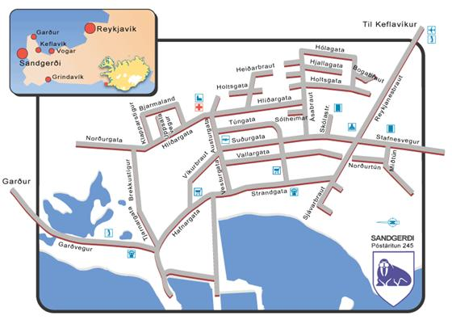

Húsavík Research Centre, University of Iceland
The Húsavík Research Centre is located on the northern coast of Iceland on the edge of the Bay of Skjálfandi. Skjálfandi is world renowned for its diversity and abundance of marine mammals, and the University Centre offers a prime location to observe and study whales and other cetaceans.
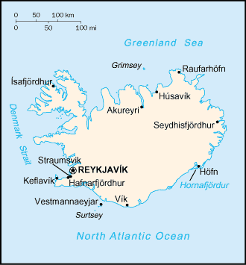

Website: http://www.dolphinresearch.dk/husavik/husavik_001.html

General Information
Accommodation
In Reykjavik, students registered on the summer course(s) will be able to stay at Hússtjórnarskólinn on Sólvallagötu (www.husstjornarskolinn.is) at an approximate price of 2500 ISK per night. Please contact us at post@marine.is for further information.
For accommodation in Húsavík, please contact Dr. Marianne Rasmussen (mhr@hi.is).
Exchange rates: see www.landsbanki.is/english/markets/exchangerates/
International flights: Icelandair (www.icelandair.com), Iceland Express (www.icelandexpress.com) and SAS (www.flysas.com)
International Airport: Keflavík (KEF: www.kefairport.is/English)
Transfer between airport and Reykjavik: Flybus (www.re.is/Flybus)
National flights: Air Iceland (www.airiceland.is), Eagle Air (www.eagleair.is)
Bus transport: Sterna (www.sterna.is/en), Reykjavik Excursions (www.re.is), Strætó (www.straeto.is/English)
Taxi: Hreyfill (www.hreyfill.is/hreyfill/en)
University of Iceland (Háskóli Íslands) (www.hi.is/en/introduction)
Visa Requirements: The Directorate of Immigration (www.utl.is)
Public holidays: see http://www.iceland.is/history-and-culture/Traditions/IcelandicHolidays/
Emergency number: Call 112 or see http://en.ja.is/i-neyd/for other numbers

For further useful information visit http://marice.is/information.htm

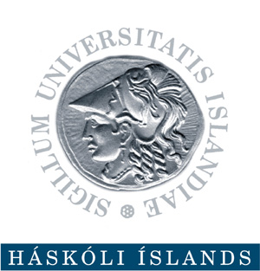 | University of Iceland  Marine Education in Iceland  Institute of Biology  Askja, Sturlagata 7  IS-101 Reykjavik, Iceland  Email: post@marine.is

Application for Admission
University of Iceland Marine and Fisheries Sciences Summer Program

Which courses are you applying for?
LÍF 632M: Data Analysis for Scientists using R
Y/N
LÍF 602M: Fisheries Ecology
Y/N
LÍF 111M: Marine Mammals
Y/N

Personal Information
Name:
Gender (M/F):
Date of Birth:
Nationality:
E-mail:
Telephone (inc. country code):

Contact Address (You must be able to receive documents at this address after the course has finished so please ensure it is correct):
Mobile phone (inc. country code):
Education
Current University/Institution (Name, country):

Degree (BSc/MSc/PhD/Other):
Expected graduation (month & year):
Former University/Institution (Name, country):
Degree (BSc/MSc/PhD/Other):
Graduation (year):

DOCUMENTS THAT MUST ACCOMPANY YOUR APPLICATION FORM
1) Official Academic Transcript(s)

Even if you have not yet completed your degree, your University will able to provide you with a transcript of the courses you have taken so far and the grades you have obtained. The transcript can also be for your last completed degree (as long as it has relevance to the course(s) you have applied for here in Iceland).

Please scan your official academic transcript(s), and e-mail it to us with this application form

2) Application for 'Kennitala‘ and colour photocopy of your Passport
Before we can register you for the course(s) for which you are applying at the University, we have to apply for a Kennitala − Icelandic social security number − for you (this number is only valid for the duration of the course).
Go to: http://skra.is/lisalib/getfile.aspx?itemid=5849, print and complete SECTIONS 1 – 10 of the form only (do NOT sign it).
Please scan this form and a COLOUR copy of your passport, and e-mail them to us with this application form.

3) Confirmation from your University that they will recognise the course(s)*
If the ECTS you gain from this course/these courses will be used for your studies at your home University, you need to confirm with your University that they will recognise our course(s) for that purpose. Here is the information you need:
LÍF 632M: Data Analysis for Scientists using R
4 ECTS, Final grading system: Pass or Fail

LÍF 602M: Fisheries Ecology
8 ECTS, Final grading system: Grade between 1 and 10

LÍF 111M: Marine Mammals
6 ECTS, Final grading system: Pass or Fail
Please include a letter from your University that states they will accept these courses and associated ECTS with this application form.
*If you will not officially use the ECTS from our course(s) for your graduate (or undergraduate) studies, please state this in your email or on this form (a letter from your University is then not required).

